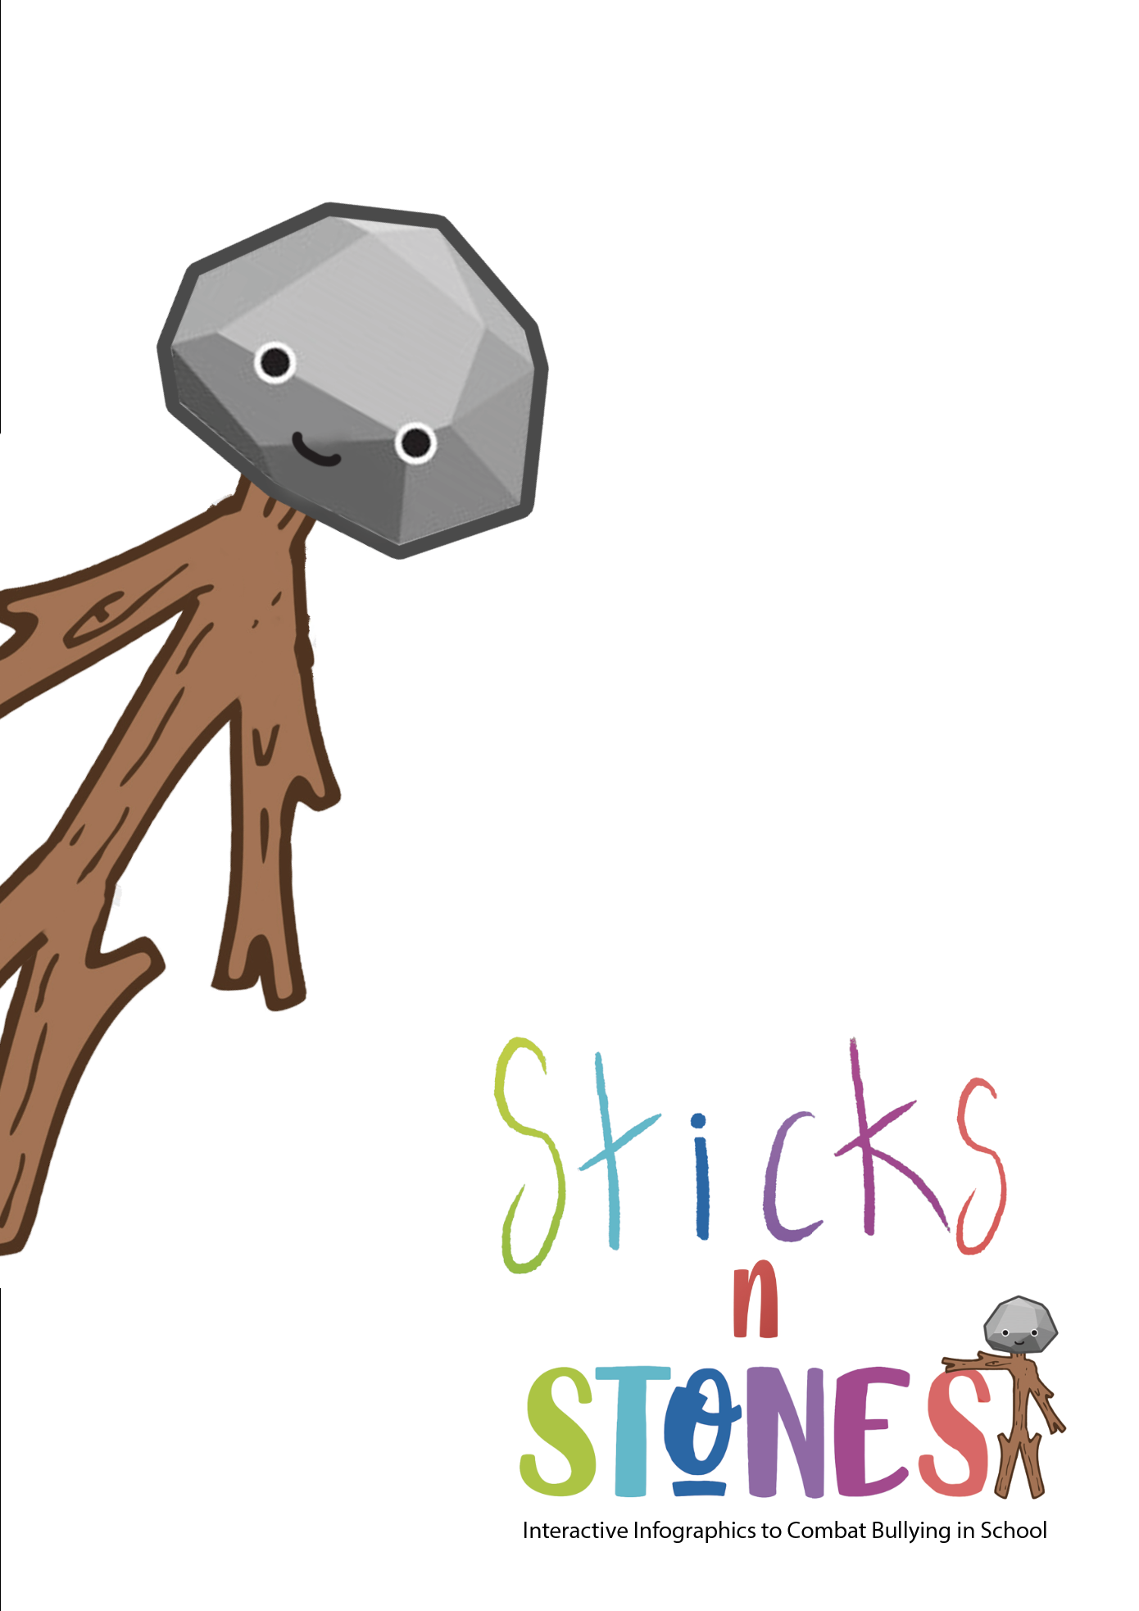

Context and description

The aim of this Professional Training and Education Programme for primary school teachers is to improve teachers' knowledge and skills so that they can make the most of the potential of digital infographics and develop their own learning resources through the creation of digital educational content.

The programme consists of 50 hours of learning:
- 21 hours in person
- 29 hours of self-directed learning
(additional, self-directed content for each topic that will allow primary teachers to further improve their knowledge of the topics covered. )

Content of self-directed learning:

 | Reading + tasks | Evaluation
Modules 1  Online Safety and Digital Lesson Planning | 8 hrs | 2 hrs
Module 2  challenge-based learning | 8 hrs | 2 hrs
Module 3  digital content creation | 7 hrs | 2 hrs
 | 23 hrs | 6 hrs
TOTAL | 29 hrs

For each module, we provide teaching materials, resources and tasks/activities.

*In terms of assessment, each module contains an assessment tool corresponding to 2 hours of work.

Section Title: Online safety and digital lesson planning
Designed by: RAFINA
Aim of the Module |  | This module will provide teachers with all the theoretical knowledge they need to understand the concept of summarising information through infographics, the benefits it offers to the educational process and to primary students' understanding and learning of information, and the different types of graphics they can use depending on their needs. Finally, they will also learn simple ways to create interactive infographics. This will make it easier for them to apply the "Toolkit of Interactive Infographics Resources for Combating Bullying" in their classrooms and to adapt their digital knowledge to the material on bullying.  In particular, it will analyse:  - What is an interactive infographic: Definition, description, types and illustrated examples.  - The usefulness of infographics in education and the benefits for the learning process.  - How to create an infographic, adapt the educational content, choose an appropriate format and use it in the classroom.
TOTAL Learning time  of which: |  | SDL | Assessment
10hrs |  | 8 hrs | 2 hrs
LEARNING OUTCOMES OF THE MODULE
On successful completion of this Module, trainees (primary teachers) will be able to achieve:

knowledge | K1.1. Basic knowledge of the definition of (interactive) infographic and its characteristics  K1.2 Theoretical knowledge of the types of interactive infographics and their use.  K1.3. Basic knowledge of the use and importance of interactive infographics in education.
skills* | S1.1. Explanation of what an interactive infographic is  S1.2. Analysis of the types of interactive infographics and selection of the appropriate type for the educational need.  S1.3 Support the value of interactive infographics for primary education (including an example of existing educational interactive infographics).
Attitudes | A.1.1. Assessment of the educational value of Interactive Infographics for combating bullying.  A.1.2. Selection and application of appropriate schematic illustrations to achieve student awareness and combat bullying.  A.1.3. Justification of the importance of interactive infographics and willingness to use these new pedagogical methodologies in the classroom.

Online safety and digital lesson planning
Welcome and Introduction to the module | Welcome to "Online Safety and Digital Lesson Planning" - Module 1 of the professional development programme!  This module is aimed at primary school teachers teaching pupils aged 8-12 and has a total duration of 10 hours.  In this section you will learn about the following topics:  - What are information diagrams - interactive infographics (definition - characteristics).  - What are the different types of diagrams and what are each suitable for?  - How important is the integration of infographics in the classroom?  The learning objectives of the module are:  - To understand the usefulness of infographics and the many possibilities they offer.  - To raise awareness of the use of new and attractive digital media in the educational process and the benefits they offer to students.  - To understand the elements that make a diagrammatic representation appropriate and effective in achieving a learning objective with primary school children.  - Introduce the use of infographics to raise pupils' awareness and encourage their direct response to bullying issues so that they can be an inspiration to take action themselves.
Presentation of the learning content and tasks | - Schematic representations of information - infographics  It has been proven that people process images 60,000 times faster than text. So it's nice to have scientific backing for the old saying "a picture is worth a thousand words", because it gets to the heart of the fact that graphics are an interesting learning approach for our times.  What is an infographic? An infographic is a large picture that summarises a topic. It is a one-page publication that presents information in a graphic way. Simple icons, symbols, maps and diagrams are combined to explain the data. Text is used only as captions or for brief descriptions of events. The viewer explores the content by studying each section of the cartoon-like images.  But why an infographic? An infographic, created to educate and inform, uses the logic of design to simplify complex data and present it in an easily digestible format. No one likes to look into an endless abyss of statistics or information - luckily an infographic can summarise information and save us from drowning in a sea of words and numbers.  So an infographic is a simple but effective way of communicating. There are many reasons to use them:  -Lures the viewer's interest  -Describes many events in a small space  -transfers data quickly through pictures  -Informs without much written information  -Inspires the viewer to think about the subject as they have to explore each part  -Makes a complex subject easy to understand  The key to an effective infographic  Infographics should always aim to show rather than tell. While text plays an important role in any design, the visual aspects of an infographic should be able to communicate effectively without relying too much on typography.  Creating an infographic is not just about producing something that looks good. Training designers also need to be able to find the best way to visualise and present data, depending on the topic they are looking at. The central idea behind an infographic should be reflected in the data presented, so they need to be able to interpret the relationship between different groups of information. Eye-catching infographics not only present data, but also connect emotionally with the audience. They should evoke a reaction in learners, an emotion that reminds them of the most important information through the combination of visual elements such as sketches or diagrams, the choice of colours and typography.  Watch the following videos and think about it!  https://www.youtube.com/watch?v=e2AXdjVyE88&ab_channel=SvetlanaBikulich  https://www.youtube.com/watch?v=pLDxBbQcwNY&ab_channel=Easelly%3AInfographicDesignTips%26Tutorials  Then practice by answering the quiz below:  https://quizizz.com/admin/quiz/55e8f0c0514b7fbe374fb280/infographics  2. Types of Infographic and their use:  The flexibility of graphs is what makes them so attractive as a design solution. There are different ways to present data, such as:  Chronologies  Flowcharts  Maps  Graphical representations  Diagrams  Illustrations  Side-by-side comparisons  Ordered lists  It's not always easy to put data into a digestible and visually appealing format - but it is effective. People love quick, accessible information and infographics provide just that kind of data visualisation. Even complex data is easier to understand when combined with a pie chart, graph or photo.  Graphs that appeal to students should be concise, easy to understand and, above all, memorable. When you are done with your data, you need to decide how to present it. There are countless ways to do this: Pie chart, graph, line chart, histograms, heat map, flow chart, periodic table and so on. Each of these approaches is perfect for certain types of data.  Read the following articles about the different types of infographics and how to use them:  https://www.easel.ly/blog/types-of-infographics/  https://piktochart.com/blog/8-types-of-infographics-which-right-for-you/  https://venngage.com/blog/9-types-of-infographic-template/  In addition, you can also consult the following video:  https://www.youtube.com/watch?v=4uoCac3lafg&ab_channel=Piktochart%F0%9F%91%89All-in-onevisualcommunicationtool  Then practice by answering the quiz below:  https://quizizz.com/admin/quiz/5e5526fb8c9702001ba55f3e/infographic  SOURCES FOR STUDY:  https://www.librarydevelopment.group.shef.ac.uk/Assets/pdfs/infographics.pdf  https://www.researchgate.net/publication/266082644_Infographics_An_introduction  3. The importance of Infographics and their use in education  Infographics can be effective educational tools thanks to their ability to break down complex information into easily understandable elements and present dense data in an appealing way.  The benefits of using infographics in education:  1. Appeal to different learning styles  Different students have different learning styles. Some of them process written and oral messages quickly. Others prefer visual or tactile methods. Infographics are a great way to help your students process information in a way that is more accessible to them. This means providing words, pictures and even interactive elements to support attention, memory and recall. You can also use diagrams with written content so that they complement each other.  2. Maintain attention  In the midst of such an abundance of stimuli and information, how are your students supposed to focus on what you have to say? Infographics can help. They take the overwhelming amount of facts, data and information in texts and present them in a way that captures and holds children's attention.  3. Improve retention and recall of information  Studies show that most people remember only 10% of what they hear and 20% of what they read. But they remember 80% of what they see. Moreover, most people understand visual material much faster than other methods.  4 Simplify complex issues  Infographics often prove so effective in educational contexts because they use images to highlight, explain or enhance text-based information. They attract attention, convey information and promote retention of data by multiple learners. This makes infographics ideal for teaching basic complex processes or high-level data analysis to a general audience.  5. Reinforce the narrative  Infographics rely on narrative and flow to take the viewer from the headline to the last word or image on the page. They show how each piece of information is connected and why it belongs in the infographic. Storytelling helps your learners engage with the information you are conveying or explaining. It allows them to immerse themselves in the topic or follow the threads to understand how multiple pieces of information come together to form a coherent story. Storytelling also improves recall and retention. This type of communication engages both the left and right hemispheres of the brain and creates stronger connections.  6. Use visuals for a variety of purposes.  You can use infographics to teach your audience about any topic in any discipline. Use visual aids to present information about:  Historical chronologies  Infographics are ideal for highlighting key events in a historical period. They can help students understand how individual events are connected and influence each other, and how their impact affects the world today.  To make this type of graph even more effective, narrow down the time period or topic. For example, you can cover a year or a decade in your plan. This way you can focus the content and make it easier to follow, understand and memorise.  Statistics  Statistics can tell you a lot about a topic, but numbers alone are not always the most interesting reading material. Adding graphs and short text explanations makes statistics easier to understand and memorise.  A data-oriented infographic can also give your audience an insight into a higher-level topic and help you appear as an expert in that field.  Convince  With an infographic, you can educate your students about an important topic while showing them how and why they should take action.  Tips  Infographics can help children think creatively and find new ways to apply their skills and knowledge to tasks. Creating a visual guide with tips or tricks on how to complete a project or achieve a goal can be beneficial.  Instructions  Infographics can show your students how a complex process works. Associate each action step with a corresponding picture so they can see the goal of each step and understand how to perform it. These types of graphics can be particularly useful for training because they explain each step of the process in multiple formats. By using words, pictures and sometimes interactive elements, you can present each piece of information as clearly as possible.  Events  Infographics can help your audience learn more about an event. You can use graphics to prepare your students for an upcoming event they are attending or will be attending by explaining information such as behavioural expectations, dress code or payment collection.  Reflect by reading the following article and watching the videos:  https://www.easel.ly/blog/infographics-effective-classroom/  https://www. youtube. com/watch? v=U-Vlyu0H3wo& ab_channel=Easelly%3AInfographicDesignTips%26Tutorials  https://www. youtube. com/watch? v=VYhD0iqScDg& ab_channel=TEDxTalks  You can also study the following example of converting information into an infographic:  https://www.jmmnews.com/how-to-turn-journal-article-into-infographic/  SOURCES FOR STUDY:  https://www.researchgate.net/profile/Husni-Naparin/publication/322334733_Infographics_in_Education_Review_on_Infographics_Design/links/5b610adca6fdccf0b204bb94/Infographics-in-Education-Review-on-Infographics-Design.pdf  https://www.sciencedirect.com/science/article/pii/S1877050916325947  https://www.ijopr.com/download/the-effectiveness-of-using-infographics-on-academic-achievement-a-meta-analysis-and-a-meta-thematic-11407.pdf  * After you have studied all the sources and watched the videos, write a two-page report on your view on the importance of infographics in education, suggesting at the same time ways of using different types of graphics in the learning process in relation to bullying.
Final assessment  of achieved LOs through the Module | - Module 1: Online Safety and Digital Lesson Planning  Design an interactive infographic similar to ones from the Sticks'n'Stones "Toolkit of Interactive Infographics Resources to Combat Bullying"

