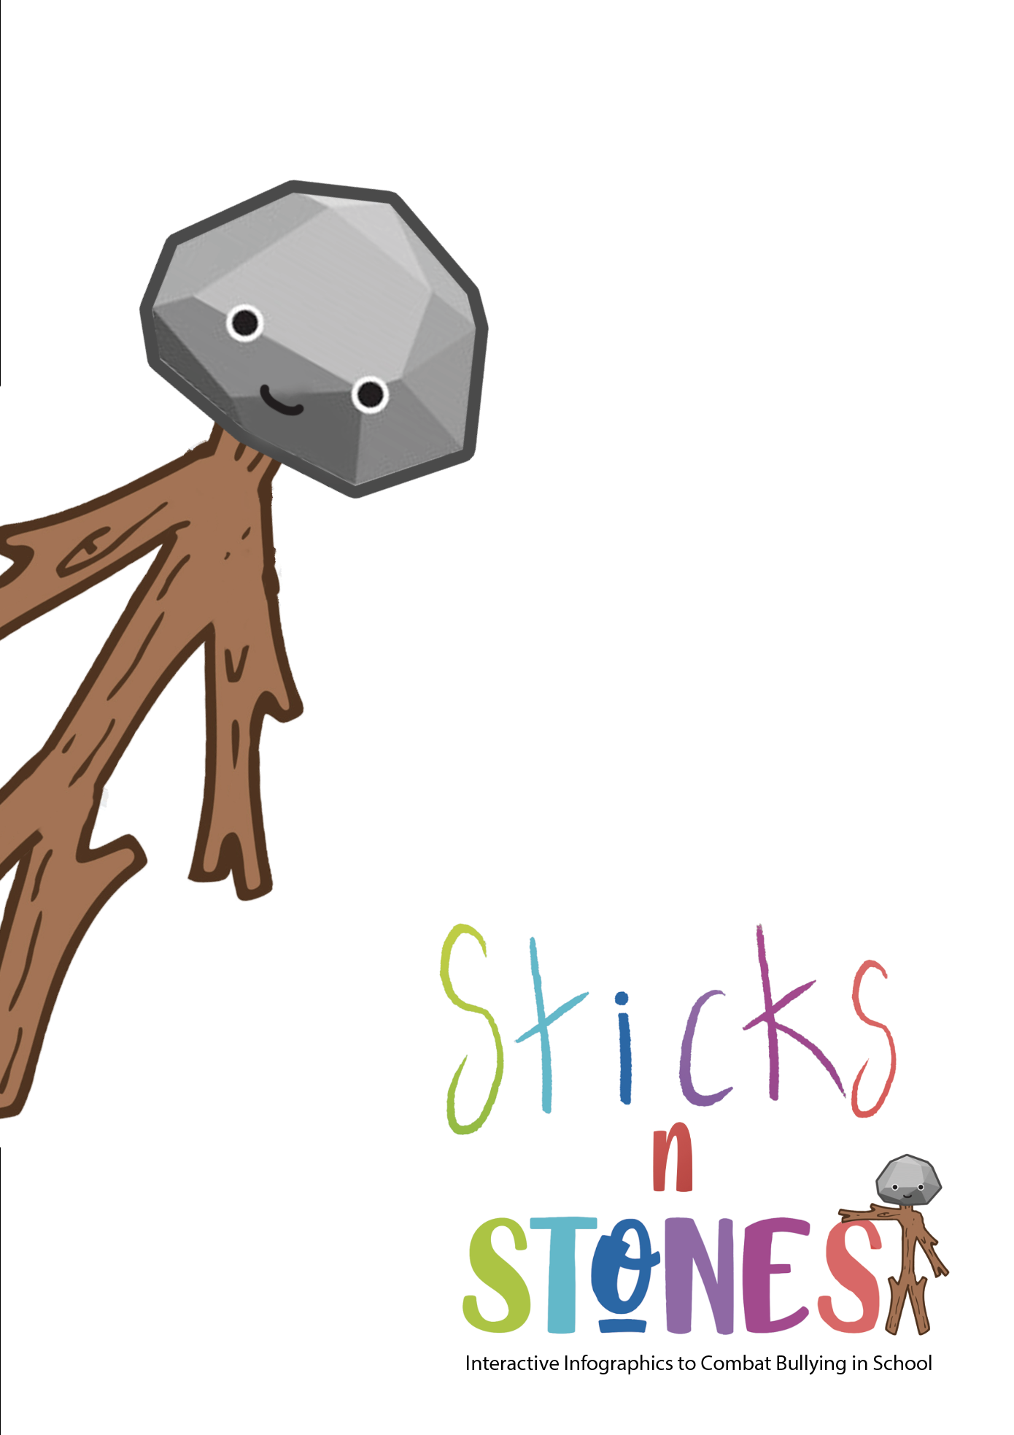
IO2: Continuing Professional Development (CPD) Training Programme for Primary Teachers

Module 1: Lesson Plans for f2f learning

Developed by UPIT

Module title: Online Safety and Digital Lesson Planning
Designed by: University of Pitești
Aim of the Module |  | This module aims to build up primary teachers’ skills on how “Toolkit of Interactive Infographics Resources to Combat Bullying” can be applied to primary school classrooms. The module includes sample lesson plans and will introduces the Lesson Plan Canvas to Primary Teachers, so that they can complete this planning template to help them to integrate these resources into their teaching practice. The Lesson Plan Canvas is based on the Business Model Canvas, but it has been adapted to be applied to a primary teaching session, and it is an effective tool for integrating technology into the classroom. This module also provides an introduction to some online safety and security tips for primary teachers to be aware of as they introduce digital resources into their teaching practice.  This module contains 3 main activities (or lessons plans): A1.1, A1.2, A1.3.
TOTAL Learning time  of which: |  | Face-to-face | Assessment
7 hrs |  | 6 hrs 45 min | 15 min
Title of activity A1.1:  Using interactive infographics in primary education |  | 2 hrs 15 min | 15 min
Title of activity A1.2:  Safe online learning environments in primary education |  | 2 hrs 15 min
Title of activity A1.3:  Creating digital lesson plans to use interactive infographics in primary education |  | 2 hrs 15 min
LEARNING OUTCOMES OF THE MODULE
On successful completion of this Module, trainees (primary teachers) will be able to:
Knowledge | K1.1. Define (interactive) infographic  K1.2. Describe features of interactive infographics  K1.3. List the types of interactive infographics  K1.4. Define online learning environment  K1.5. Describe features of online learning environment  K1.6. List the types of online learning environments
Skills | S1.1. Explain what are (interactive) infographics used for  S1.2. Argue upon the value of interactive infographics for (primary) education  S1.3. Provide example of existing educational interactive infographics  S1.4. Create interactive infographics for primary education  S1.5. Provide examples of online learning environment  S1.6. Explain what safety and security of online learning environments are
Attitudes | A1.1. Appreciate the educational value of Sticks’n’Stones “Toolkit of Interactive Infographics Resources to Combat Bullying”  A1.2. Apply Lesson Plan Canvas to design digital lesson plans  A1.3. Justify the importance of using Sticks’n’Stones Toolkit interactive infographics in classroom  A.1.4. Express appreciation upon using safety online learning environment  A1.5. Adopt efficient ways to engage students in an online learning environment  A1.6. Act independently to create safe online learning environments

Activity Code | Activity Title | Learning Outcomes to be achieved through this activity | Learning Time  for this activity  (min)
A1.1 | Using interactive infographics in primary education | K1.1. Define (interactive) infographic  K1.2. Describe features of interactive infographics  K1.3. List the types of interactive infographics  S1.1. Explain what are (interactive) infographics used for  S1.2. Argue upon the value of interactive infographics for (primary) education  S1.3. Provide example of existing educational interactive infographics | 2 hrs 15 min
Overview of Content | - The trainer welcomes participants and briefly introduces him/herself (2 min)  - S/he emphasized that this Module is developed in the framework of the Sticks’n’Stones project, briefly presenting the module and announcing the aim of the Module 1 (Sticks'n'Stones_IO2_Module 1_f2f – UPIT.pptx, slides 1-4) (5 min)  - The trainer implements the ice-breaking exercise (Sticks'n'Stones_IO2_Module1_Annex1.1_UPIT.docx) (13 min)  - The trainer presents the main concepts on Infographics and Interactive Infographics: definition, types, features, why they are valuable for education (Sticks'n'Stones_IO2_Module 1_f2f – UPIT.pptx, slides 5-14) (30 min)  - S/he explains Task 1 (slide 15). The trainees performs/solves Task 1. (15 min)  - The trainer presents then why to use Interactive Infographics in primary education; s/he presents and discusses examples of Interactive Infographics by involving trainees to analyse the examples and express their opinion on them (35 min)  - S/he explains Task 2 (slide 21). The trainees performs/solves Task 2. (30 min)  - The trainer emphasizes on the takeaways from this activity and reflects on them by involving trainees in discussion (5 min)
Content delivery methods (lecture (if pre-recorded PPT or video) or reading, literature review, problem-solving, etc.)
- Lecture
- Debate/discussion
- Individual work
- Reflection
- Group work
Didactic Materials Required (Sticks’n’Stones Toolkit, worksheet, charts, handouts, didactic video, excerpt from books/manuals, mind maps, etc.)
Sticks'n'Stones_IO2_Module 1_f2f – UPIT.pptx
Sticks'n'Stones_IO2_Module1_Annex1.1_UPIT.docx
as shown above, under section “Overview of Content”.
Assessment method
By evaluating the completion of the tasks explained in slides 15, 21
By taking the test at the end of the module
References
- Cambridge Dictionary, https://dictionary.cambridge.org/dictionary/english/infographic
- Oxford Dictionary, https://www.lexico.com/definition/infographic
- What is an Infographic? Examples, Templates & Design Tips, https://venngage.com/blog/what-is-an-infographic/
- How to Create an Interactive Infographic: The Definitive Guide, https://rockcontent.com/blog/interactive-infographic/
- Interactive Infographic, http://www.itvantage.co.uk/services/interactive-infographic
- 8 Types of Interactive Infographics, https://blog.dot.vu/8-types-of-interactive-infographics/
- 8 Types of Interactive Infographics, https://blog.dot.vu/8-types-of-interactive-infographics/
- The 12 Best Types of Interactive Content for Higher Engagement: Infographics, Widgets, & More, https://killervisualstrategies.com/blog/best-types-interactive-content-infographics-design.html
- 16 Stunning Examples of Interactive Infographics, https://medium.com/visual-stories/16-stunning-examples-of-interactive-infographics-fa7203845cb1

Activity Code | Activity Title | Learning Outcomes to be achieved through this activity | Learning Time  for this activity  (min)
A1.2 | Safe online learning environments in primary education | K1.4. Define online learning environment  K1.5. Describe features of online learning environment  K1.6. List the types of online learning environments  S1.5. Provide examples of online learning environment  S1.6. Explain what safety and security of online learning environments are  A1.4. Express appreciation upon using safety online learning environment  A1.5. Adopt efficient ways to engage students in an online learning environment  A1.6. Act independently to create safe online learning environments | 2 hrs 15 min
Overview of Content | - The trainer announces the title of the activity (slide 22);  - The trainer presents the definition, features, types and examples of online learning environments; ways and advice to engage pupils in an online learning environment (Sticks'n'Stones_IO2_Module 1_f2f – UPIT.pptx, slides 23-27) (15 min)  - S/he explains Task 3 (slide 28). The trainees performs/solves Task 3.  (5 min)  - The trainer continues presentation (slides 29-42) (40 min)  - S/he explains Task 4 (slide 43) and distributes Annex 1.2 to trainees. The trainees performs/solves Task 4. (45 min)  - The trainer continues and presents the online safety and how to ensure it for pupils (slides 44-52) (25 min)  The trainer emphasizes on the takeaways from this activity and reflects on them by involving trainees in discussion (5 min)
Content delivery methods (lecture (if pre-recorded PPT or video) or reading, literature review, problem-solving, etc.)
- Lecture
- Individual work
- Group work
- Whole class work
- Reflection
- Debate/discussion
Didactic Materials Required (Sticks’n’Stones Toolkit, worksheet, charts, handouts, didactic video, excerpt from books/manuals, mind maps, etc.)
Sticks'n'Stones_IO2_Module 1_f2f – UPIT.pptx
Sticks'n'Stones_IO2_Module1_Annex1.1_UPIT.docx
Sticks'n'Stones_IO2_Module1_Annex1.2_UPIT.docx
as shown above, under section “Overview of Content”.
Assessment method
By evaluating the completion of the tasks in slides 28, 43.
By taking the test at the end of the module
References
- IGI Global, What is Online Learning Environment, https://www.igi-global.com/dictionary/interacting-at-a-distance/21004
- Top 10 eLearning Features That Everyone Should Know About, https://elearningindustry.com/elearning-features-top-everyone-know
- Online Learning Is The Future Of Education: Here’s Why, https://elearningindustry.com/why-online-learning-is-future-of-education
- Innovate Learning Environment, https://fahiezan.wordpress.com/week-3/
- All 10 Types of E-Learning Explained, https://e-student.org/types-of-e-learning/
- 10 Best Examples of eLearning Platforms Today, https://axiomq.com/blog/10-best-examples-of-elearning-platforms-today/
- MOODLE, https://docs.moodle.org/311/en/Features
- Five Ways to Engage Students in an Online Learning Environment, https://www.facultyfocus.com/articles/online-education/online-course-delivery-and-instruction/five-ways-to-engage-students-in-an-online-learning-environment/
- 10+ New Ideas for Increasing Student Engagement in Online Courses, https://www.digitalclassworld.com/blog/how-to-engage-students-online/
- Maintaining A Safe Learning Environment for Distance Learning, https://learnsafe.com/maintaining-a-safe-learning-environment-for-distance-learning/#:~:text=It%20is%20important%20to%20define,online%20behaviors%20for%20the%20future
- Creating a Safe Online Environment for Kids, https://www.itu.int/en/cop/Documents/Creating%20a%20Safe%20Online%20Environment%20for%20Kids%20ITU.pdf

Activity Code | Activity Title | Learning Outcomes to be achieved through this activity | Learning Time  for this activity  (min)
A1.3 | Creating digital lesson plans to use interactive infographics in primary education | A1.1. Appreciate the educational value of Sticks’n’Stones “Toolkit of Interactive Infographics Resources to Combat Bullying”  A1.2. Apply Lesson Plan Canvas to design digital lesson plans  A1.3. Justify the importance of using Sticks’n’Stones Toolkit interactive infographics in classroom  S1.4. Create interactive infographics for primary education | 2 hrs 15 min
Overview of Content | - The trainer announces the title of the activity (slide 53);  - The trainer presents the Sticks’n’Stones “Toolkit of Interactive Infographics Resources to Combat Bullying” and explains what the Toolkit is and how it has to be used by primary teachers (Sticks'n'Stones_IO2_Module 1_f2f – UPIT.pptx, slides 54-64) (25 min)  - S/he explains Task 5 (slide 65). The trainees performs/solves Task 5.  (35 min)  - The trainer continues presentation and explains how to make interactive infographics with Canva (slide 66) (5 min)  - S/he explains Task 6 (slide 67). The trainees performs/solves Task 6. (15 min)  - The trainer continues and presents how to design digital lesson plans by using Lesson Plan Canvas and include Interactive Infographics from Sticks’n’Stones Toolkit and other digital learning resources (slides 68-70) (10 min)  - S/he explains Task 7 (slide 71). The trainees performs/solves Task 7.  (40 min)  The trainer emphasizes on the takeaways from this activity and reflects on them by involving trainees in discussion (5 min)
Content delivery methods (lecture (if pre-recorded PPT or video) or reading, literature review, problem-solving, etc.)
- Lecture
- Individual work
- Group work
- Whole class work
- Reflection
- Debate/discussion
Didactic Materials Required (Sticks’n’Stones Toolkit, worksheet, charts, handouts, didactic video, excerpt from books/manuals, mind maps, etc.)
Sticks'n'Stones_IO2_Module 1_f2f – UPIT.pptx
as shown above, under section “Overview of Content”.
Assessment method
By evaluating the completion of the tasks in slides 65, 67, 71
By taking the test at the end of the module
References
- Sticks’n’Stones Toolkit, link to be added here!
- Powtoon, https://www.powtoon.com/?locale=en
- Kahoot, https://kahoot.it/
- Google Workspace, https://workspace.google.com/
- Canva, https://www.canva.com/
- How to make interactive infographics with Canva, https://www.freetech4teachers.com/2019/12/how-to-make-interactive-graphic-with.html
- How to make a lesson plan, www.canva.com/create/lesson-plans/
- Canva Tutorial for Teachers | Create a Lesson Plan on Canva, https://www.youtube.com/watch?v=bt4M2_f9lwY

Final evaluation test for Module 1: Online Safety and Digital Lesson Planning

Methodical instructions:

🡺 Each item consists of a statement (the ‘stake’) and 4 answering options, of which only one is correct.
🡺 Read the text of each item carefully and identify the correct option.
🡺 Tick the correct option ( ⌧ ). This option represents the solution of that item.
🡺 Recommended total time per test: 15 minutes.
🡺 Possible maximum score = 9 points. Each item correctly solved values 1 point.
🡺 FINAL GRADE = Score + 1 point ex officio.

- An interactive infographic is:
◻ (a) a graphic layout containing statistical information;
◻ (b) a data-rich, visually compelling and engaging infographic that also utilizes animation so users can “interact” with the design;
◻ (c) a tool for teachers to assess inadequate behaviours of their pupils;
◻ (d) a method for school board to assess teachers’ performance in teaching-learning process that they provide to pupils.
- Among the features of the Interactive Infographic, there are included:
◻ (a) data visualisation, interactivity, interchangeability;
◻ (b) creativity, communicativeness, non-linearity;
◻ (c) mobility, being a semiotic system;
◻ (d) interactivity, linearity, multimodality.
- Statement:
◻ (a) Answer-option 1;
◻ (b) Answer-option 2;
◻ (c) Answer-option 3;
◻ (d) Answer-option 4.
- A statistical infographic:
◻ (a) is contains lots of pie charts, pictograms, maps, and bar graphs;
◻ (b) is telling a story in chronological order;
◻ (c) compares two similar things side-by-side to highlight the difference between them;
◻ (d) organizes information according to the various levels of hierarchy.
- The use of Interactive Infographics in primary education allows pupils to:
◻ (a) reiterate teachers’ explanations provided during the previous class;
◻ (b) score teachers’ performance during the class;
◻ (c) interpret them and argue from evidence to support their interpretation of the infographic;
◻ (d) integrate new knowledge in school curriculum.
- An online learning environment (OLE) is:
◻ (a) learning material that is accessible in digital format;
◻ (b) a software application that enhances learning;
◻ (c) the virtual learning space where students exchange knowledge and expertise using the virtual classroom;
◻ (d) the physic learning space where students share knowledge and expertise from databases.
- Online Learning Environment offers:
◻ (a) collaboration, strong reporting, pupil-parent interactions;
◻ (b) better learning experience, increased mobility, increased effectiveness;
◻ (c) better cost-efficiency, less responsive features, the fact that more pupils can enrol at once;
◻ (d) natural user interface, responsive design features, availability features.
- Synchronous and asynchronous online learning represent:
◻ (a) types of online learning;
◻ (b) digital resources;
◻ (c) types of assessment tools;
◻ (d) online apps.
- Teachers can assure the safety of their pupils by:
◻ (a) allowing pupils access to the use of digital resources and online learning environments only in the presence of the teacher / parent;
◻ (b) creating assignments and activities about online safety;
◻ (c) keeping pupils away from online security resources so as not to give them ideas for do bullying deeds;
◻ (d) avoiding discussions about cyberbullying so as not to scare pupils.
- Each Sticks’n’Stones Interactive Infographics contains the following elements:
◻ (a) an introductory video; and infografic; a mind map; a digital breakout;
◻ (b) a quiz / puzzle; a worksheet; a case study;
◻ (c) an introductory video; a quiz / puzzle; a digital breakout; a Webquest;
◻ (d) an essay; a Webquest; a lesson plan.

Correct answers (for trainers only):
- b
- d
- a
- c
- c
- d
- a
- b
- c

