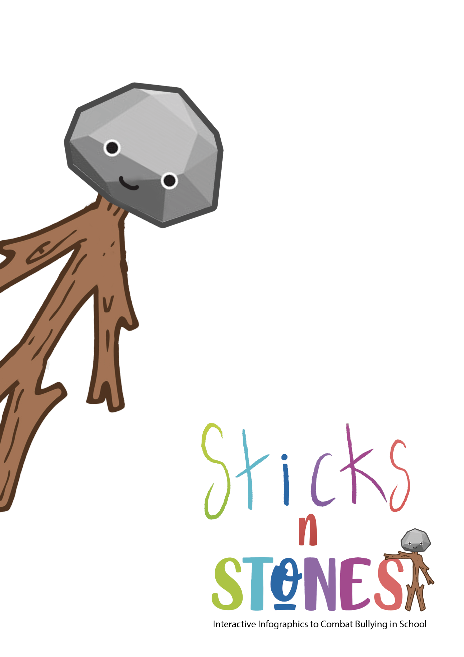
IO2: Continuing Professional Development (CPD) Training Programme for Primary Teachers

Module 2: Lesson Plans for f2f learning

Developed by UPIT

Module title: Challenge-Based Learning
Designed by: University of Pitești
Aim of the Module |  | This module aims to introduce the didactic theory of challenge-based learning to primary school teachers and to include instructions and guidelines to be followed when developing their own challenge-based learning resources.  This module contains 3 main activities (or lessons plans): A2.1, A2.2, A2.3.
TOTAL Learning time  of which: |  | Face-to-face | Assessment
7 hrs |  | 6 hrs 45 min | 15 min
Title of activity A2.1:  Challenge-Based Learning approach (CBL): introduction to it and theoretical aspects |  | 2 hrs 15 min | 15 min
Title of activity A2.2:  CBL’s key-implications and benefits for teaching and learning |  | 2 hrs 15 min
Title of activity A2.3:  How to create CBL lesson plans and resources |  | 2 hrs 15 min
LEARNING OUTCOMES OF THE MODULE
On successful completion of this Module, trainees (primary teachers) will be able to:
Knowledge | K2.1. Describe what CBL is  K2.2. Indicate existing examples of CBL  K2.3. Outline CBL characteristics  K2.4. Emphasize the key-implications of CBL on teaching and learning  K2.5. Describe benefits of CBL  K2.6. List category of resources for CBL
Skills | S2.1. Explain CBL theory/principles  S2.2. Compare CBL and PBL  S2.3. Generate outline of (own) CBL example  S2.4. Present the approaches necessary for generating a CBL lesson plan  S2.5. Apply the steps necessary for generating a CBL lesson plan  S2.6. Describe categories of resources for CBL
Attitudes | A2.1. Express appreciation on CBL  A2.2. Show willingness upon using CBL in classroom  A2.3. Act independently to generate CBL lesson plans  A2.4. Act independently to generate CBL resources

Activity Code | Activity Title | Learning Outcomes to be achieved through this activity | Learning Time  for this activity  (min)
A2.1 | Challenge-Based Learning approach (CBL): introduction in it and theoretical aspects | K2.1. Describe what CBL is  K2.2. Indicate existing examples of CBL  K2.3. Outline CBL characteristics  K2.6. List category of resources for CBL  S2.1. Explain CBL theory/principles  S2.2. Compare CBL and PBL  S2.6. Describe categories of resources for CBL | 2 hrs 15 min
Overview of Content | • S/he emphasized that this Module is developed in the framework of the Sticks’n’Stones project, briefly presenting the module and announcing the aim of the Module 2 (Sticks'n'Stones_IO2_Module 2_f2f – UPIT.pptx, slides 1-4) (5 min)  • The trainer defines and describes CBL (Sticks'n'Stones_IO2_Module 1_f2f – UPIT.pptx, slides 6-7) (5 min)  • S/he explains Task 1 (slide 8). The trainees performs/solves Task 1.  (15 min)  • The trainer continues description of CBL, presentation of CBL as verb and noun and CBL principles (slides 9-17) (20 min)  • S/he explains Task 2 (slide 18). The trainees performs/solves Task 2. (15 min)  • The trainer continues lecture and presents CBLs’ phases, characteristics of the Challenge, variations of Challenge, and performs a comparison between CBL and PBL, resources and activities for PBL (slides 19-29) (40 min)  • S/he explains Task 3 (slide 30). The trainees performs/solves Task 3. (30 min)  The trainer emphasizes on the takeaways from this activity and reflects on them by involving trainees in discussion (5 min)
Content delivery methods (lecture (if pre-recorded PPT or video) or reading, literature review, problem-solving, etc.)
- Lecture
- Individual work
- Work in pairs
- Reflection
- Discussion
Didactic Materials Required (Sticks’n’Stones Toolkit, worksheet, charts, handouts, didactic video, excerpt from books/manuals, mind maps, etc.)
Sticks'n'Stones_IO2_Module 2_f2f – UPIT.pptx
as shown above, under section “Overview of Content”.
Assessment method
By evaluating the completion of the tasks explained in slides 9, 18, 30
By taking the test at the end of the module
References
- Challenge-Based Learning, https://www.challengebasedlearning.org/about/
- CBL principles, https://edusol.info/historico/bitacora/eraser/acot2-apple-classroomms-tomorrow-today
- Challenge-Based Learning, https://www2.tuhh.de/zll/cbl-start/
- CBL Guide 2016, https://www.challengebasedlearning.org/wp-content/uploads/2019/02/CBL_Guide2016.pdf
- Esraa Mohammed Soltan (2015), Challenge Based Learning vs. Problem Based Learning, Research Gate, https://www.researchgate.net/publication/320443042_Challenge_Based_Learning_VS_Problem_Based_Learning
- Challenge Based Learning, https://www.kalinda.vic.edu.au/page/78/Challenge-Based-Learning

Activity Code | Activity Title | Learning Outcomes to be achieved through this activity | Learning Time  for this activity  (min)
A2.2 | CBL’s key-implications and benefits for teaching and learning | K2.4. Emphasize the key-implications of CBL on teaching and learning  K2.5. Describe benefits of CBL  A2.1. Express appreciation on CBL  A2.2. Show willingness upon using CBL in classroom | 2 hrs 15 min
Overview of Content | - The trainer announces the title of the activity (slide 32);  - The trainer presents CBL’s key-implications on teaching and learning and why CBL is significant (Sticks'n'Stones_IO2_Module 2_f2f – UPIT.pptx, slides 33-36) (10 min)  - S/he explains Task 4 (slide 37). The trainees performs/solves Task 4.  (25 min)  - The trainer continues presentation with benefits of CBL for learning (slides 38-44) (15 min)  - S/he explains Task 5 (slide 45). The trainees performs/solves Task 5. (50 min)  - The trainer continues presentation with CBL downsides (slides 46-47) (5 min)  - S/he explains Task 6 (slide 48). The trainees performs/solves Task 6. (30 min)  The trainer emphasizes on the takeaways from this activity and reflects on them by involving trainees in discussion (5 min)
Content delivery methods (lecture (if pre-recorded PPT or video) or reading, literature review, problem-solving, etc.)
- Lecture
- Individual work
- Group work
- Pair work
- Whole class work
- Debate/discussion
Didactic Materials Required (Sticks’n’Stones Toolkit, worksheet, charts, handouts, didactic video, excerpt from books/manuals, mind maps, etc.)
Sticks'n'Stones_IO2_Module 2_f2f – UPIT.pptx
as shown above, under section “Overview of Content”.
Assessment method
By evaluating the completion of the tasks in slides 37, 45, 48
By taking the test at the end of the module
References
- Things You Should Know About…Challenge-Based Learning, https://library.educause.edu/-/media/files/library/2012/1/eli7080-pdf.pdf
- Chris L. Swiden (2013), Effects of Challenge-Based Learning on Student Motivation and Achievement, A professional paper submitted in partial fulfillment of the requirements for the degree of Master of Science in Science Education, Montana State University, Bozeman, Montana, p.9
- Webinar „The Benefits of Challenge-based Learning”, 25 January 2021, https://www.nyas.org/events/2021/webinar-the-benefits-of-challenge-based-learning/?tab=description
- Challenge-Based Learning, https://www2.tuhh.de/zll/challenged-based-learning/
- Johnson, Laurence F.; Smith, Rachel S.; Smythe, J. Troy; Varon, Rachel K. (2009). Challenge-Based Learning: An Approach for Our Time. Austin, Texas: The New Media Consortium, p. 9
- Tedx talks, “Challenge based learning: Andi Bodeau and Ryan Semans”, https://www.youtube.com/watch?v=yv1E6Vth7Uw

Activity Code | Activity Title | Learning Outcomes to be achieved through this activity | Learning Time  for this activity  (min)
A2.3 | How to create CBL lesson plans and resources | S2.3. Generate outline of (own) CBL example  S2.4. Present the approaches necessary for generating a CBL lesson plan  S2.5. Apply the steps necessary for generating a CBL lesson plan  A2.3. Act independently to generate CBL lesson plans  A2.4. Act independently to generate CBL resources | 2 hrs 15 min
Overview of Content | - The trainer announces the title of the activity (slide 50);  - The trainer presents elements, steps to be taken when creating a CBL lesson plan, shares and explains lesson plan templates and provides examples of CBL lesson plans (Sticks'n'Stones_IO2_Module 2_f2f – UPIT.pptx, slides 51-56) (30 min)  - S/he explains Task 1 (slide 57). The trainees performs/solves Task 1.  (15 min)  - The trainer continues presentation (slides 58-76) (45 min)  - S/he explains Task 2 (slide 77) and provides the trainees the Challenge Planner in Annex 2.1. The trainees performs/solves Task 2. (40 min)  The trainer emphasizes on the takeaways from this activity and reflects on them by involving trainees in discussion (5 min)
Content delivery methods (lecture (if pre-recorded PPT or video) or reading, literature review, problem-solving, etc.)
- Lecture
- Exemplification
- Individual work
- Debate/discussion
Didactic Materials Required (Sticks’n’Stones Toolkit, worksheet, charts, handouts, didactic video, excerpt from books/manuals, mind maps, etc.)
Sticks'n'Stones_IO2_Module 2_f2f – UPIT.pptx
Sticks'n'Stones_IO2_Module1_Annex2.1_UPIT.pdf
as shown above, under section “Overview of Content”.
Assessment method
By evaluating the completion of the tasks in slides 57, 77
By taking the test at the end of the module
References
- CBL Guide 2016, https://www.challengebasedlearning.org/wp-content/uploads/2019/02/CBL_Guide2016.pdf
- Apples for Kids / Challenge Based Learning, Gathering Evidence with Challenge Based Learninghttps://applesforkids.org/archives/category/challenge-based-learning/
- Rise Challenge Planner, https://www.challengebasedlearning.org/wp-content/uploads/2021/02/Rise_challenge_planner.pdf
- Challenge Based Learning Organisation, https://www.challengebasedlearning.org/project/cbl-rubric/
- Challenge-Based Learning An Approach for Our Time, https://www.challengebasedlearning.org/wp-content/uploads/2019/05/CBL_approach_for_our_time.pdf

Final evaluation test for Module 2: Challenge-Based Learning

Methodical instructions:

🡺 Each item consists of a statement (the ‘stake’) and 4 answering options, of which only one is correct.
🡺 Read the text of each item carefully and identify the correct option.
🡺 Tick the correct option ( ⌧ ). This option represents the solution of that item.
🡺 Recommended total time per test: 15 minutes.
🡺 Possible maximum score = 9 points. Each item correctly solved values 1 point.
🡺 FINAL GRADE = Score + 1 point ex officio.

- Challenge-Based Learning (CBL) is:
◻ (a) a learning monitoring tool;
◻ (b) a framework and a pedagogical approach;
◻ (c) a customizable learning platform;
◻ (d) a digital resource for education.
- In Challenge-Based Learning (CBL):
◻ (a) teachers and learners move within the four walls of the classroom;
◻ (b) teacher is learner and learner is teacher;
◻ (c) there is no space and freedom to fail;
◻ (d) the focus is on product.
- One of the basic principles of Challenge-Based Learning (CBL):
◻ (a) Social and Emotional Connections with Community;
◻ (b) Summative Assessment;
◻ (c) A Culture of Digitalisation;
◻ (d) Understanding of 21st Century Skills and Outcomes.
- The phases of Challenge-Based Learning (CBL) are:
◻ (a) Debate, Analyse, Create;
◻ (b) Organize, Interpret, Formulate;
◻ (c) Design, Decide, Test;
◻ (d) Engage, Investigate, Act.
- Activities for Challenge-Based Learning (CBL) include:
◻ (a) experiments, simulations, research;
◻ (b) surveys, curriculum design, assessments;
◻ (c) interviews, assignments, contracting;
◻ (d) lectures, problem sets, software development.
- One central benefit of Challenge-Based Learning (CBL) is:
◻ (a) supports organisational strategy development;
◻ (b) increases parental engagement;
◻ (c) supports content mastery;
◻ (d) increases social empathy.
- In Challenge-Based Learning (CBL), learners move from an abstract Big Idea to a concrete and actionable Challenge through:
◻ (a) Investigation and Evaluation;
◻ (b) development of Guiding Activities and Resources;
◻ (c) a process of Essential Questioning;
◻ (d) implementation of evidence-based Solutions.
- One downside of Challenge-Based Learning (CBL) is:
◻ (a) for both learners and teachers, it requires a heavier time commitment than more traditional teaching-learning activities;
◻ (b) it requires teachers to guide learners in classroom discussion by increasing their usual control and accepting no errors;
◻ (c) it allows learners to select only topics that the teacher master perfectly;
◻ (d) it generates selection and use by the learners of those technologies that the teacher is experienced with.
- The roles of schools, teachers, and students in Challenge-Based Learning (CBL) are:
◻ (a) teachers find the Solutions for the students, not with them;
◻ (b) teachers become more than information experts, they become collaborators/co-learners in learning;
◻ (c) students focus only on central parts of the CBL process and not on all discrete parts, because they are not the “senior Learner” like the teacher is;
◻ (d) over time, the students pass on to the teacher more and more responsibility and ownership over the learning process.

Correct answers list (for trainers only):
- b
- b
- d
- d
- a
- c
- c
- a
- b

