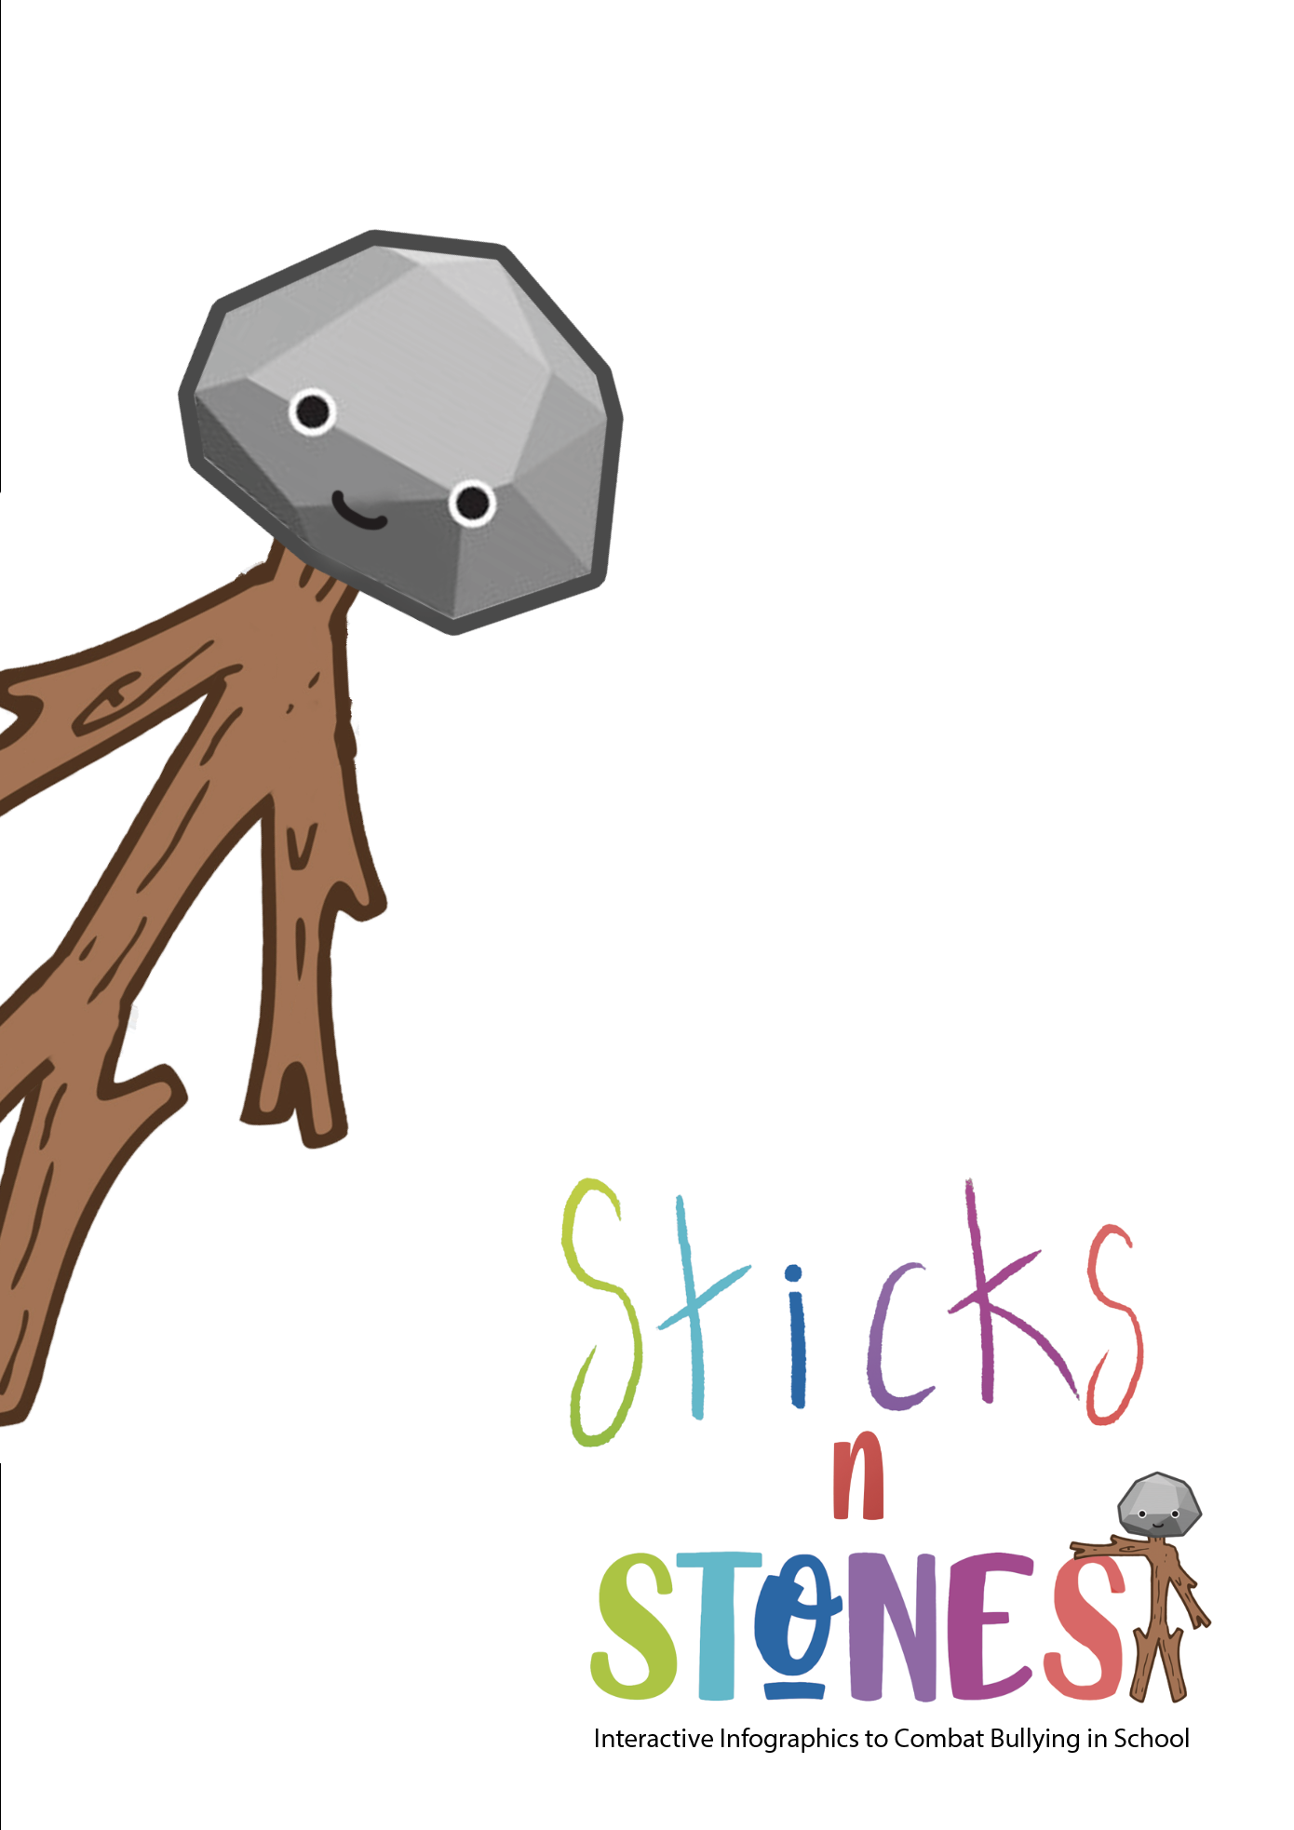

Module title: Learning through Challenges in the Classroom
Module objective |  | This module introduces the pedagogical theory of Challenge-Based Learning to support teachers in integrating WebQuests into their teaching. To this end, the Lesson Plan Canvas is also introduced in this module. The Lesson Plan Canvas is based on the Business Model Canvas but has been adapted so that it can be applied to a lesson and is an effective tool for integrating technology in the classroom.  Topics:  - Introduction to the pedagogical approach of learning through challenges.  - Integration of WebQuests into lesson plans  - Introduction to the Lesson Plan Canvas
Total time |  | Self-directed learning | Evaluation
10 hours of which: |  | 8 hours | 2 hours
Learning objectives
Upon successful completion of the completion you will be able to:
1. Introduce the pedagogical approach of Challenge-Based Learning
2. Integrate WebQuest into a lesson plan
Knowledge | C.2.1. Practical knowledge of the pedagogical framework of Learning through Challenges  C.2.2. Theoretical knowledge for integrating WebQuests into a lesson plan
Skills | D.2.1. Discussion on how Challenge-Based Learning can be used in the learning process for teaching climate issues  D.2.2. Analysis of how the Lesson Plan Canvas can be used to integrate WebQuest into a lesson plan
Attitudes | S.2.1. Awareness of new pedagogical methodologies  S.2.2. Willingness to use new pedagogical methodologies to tackle bullying

Module title: : Learning through Challenges in the Classroom
Welcome and Introduction | Welcome to "Challenge-Based Learning in the classroom" - Module 2 of the education programme!  The module has a total duration of 10 hours.  In this section you will learn about the following topics:  - Introduction to the pedagogical approach of Challenge-Based Learning .  - Integrating WebQuests into lesson plans  - Introduction to the Lesson Plan Canvas  The learning objectives of the module are:  1. Develop basic knowledge of the Challenge-Based Learning pedagogical approach  2. Develop skills to integrate WebQuests into a lesson plan.
Presentation of content and activities | Introduction to the pedagogical approach of Challenge-Based Learning  We are surrounded by challenges: big, small, local, global, short and long term. Some we choose, some choose us. Some we look forward to, some we fear. Ultimately, our future will depend on how we respond individually and collectively to the challenges. In the hectic pace of life in school, work, family and society, there is rarely time to consider different perspectives and find thoughtful solutions. When and how do we learn how to address challenges and create sustainable solutions? Without an effective, simple and efficient framework for thinking, we repeat mistakes and overlook innovative ideas. As problems become more complex and pressing, it is critical to raise a generation of engaged learners who can tackle and develop innovative and sustainable solutions. The Challenge-Based Learning framework empowers learners (students, teachers, administrators and community members) to address local and global challenges while gaining knowledge in mathematics, science, social studies, medicine, technology, engineering, computer science and the arts. By learning through challenges, students and teachers can make a difference and show that learning can be exciting and meaningful. Hundreds of millions of people worldwide participate in formal education. Most of them focus on acquiring the knowledge and skills necessary to reach the next level and eventually participate in life as a productive member of society. Challenge-Based Learning provides a holistic framework in which 21st century skills are nurtured, creating a lifelong learning framework that directly impacts the world. Imagine millions of students focusing on developing solutions to local and global challenges as part of their school work. The world is a better place. I am taking action! I am making a difference! Read more here:  CBL_Guide2016.pdf  CBL_Paper_2008 (challengebasedlearning.org)  Watch the following videos for a better understanding!  Challenge Based Learning: an overview - YouTube  An introduction to Challenge Based Learning - YouTube  Need more information? Click on the following links:  Challenge Based Learning @UT Why, What, How (utwente.nl)  About - Challenge Based Learning - Based Learning  How to Let Students Guide Science Learning with Challenge Based Learning - Digital Promise  Integrating WebQuests into the lesson plan  How is technology used in schools to impact student learning? If you walk through a typical public school, you might see teachers using presentation software to enhance a lecture, or students using a computer to publish a research paper using a word processor. These types of activities, referred to by Maddux, Johnson and Willis (1997) as Type I technology applications, are designed to make work easier and more convenient. Only rarely do teachers and students use technology to engage in meaningful learning. VanFossen (2004), referring to the lack of Internet use by teachers, stated that one possible reason for the lack of use of technology in the classroom is that "searching for content in the vastness of cyberspace is difficult. The process of finding quality information from the millions of websites available has been likened to trying to drink from a fire hose. This problem in turn makes it difficult to develop a lesson plan in relation to teachers' already limited time." Simply put, educators often lack the time to integrate technology effectively. Using technology to promote innovative teaching and learning or II type technology applications (Maddux et al., 1997) should be a priority for all teachers.  Today's students have grown up in an environment where they have easy access to the Internet, email, word processing and many other innovations. Given the advances in technology, it is reasonable to assume that in the near future most jobs will require at least professional computer skills. If technology is so important to the future success of our students, then it stands to reason that it should also be an important part of our teaching. So how can you ensure that your students use technology to gain important knowledge and skills to work in a technologically evolving society?  One Internet-based teaching strategy that is growing in popularity is WebQuest, an inquiry-based learning activity. Hundreds of schools, school districts and universities have realised the benefits of integrating it into the classroom and have online collections of WebQuests. But what is the impact of using WebQuests in the classroom on student learning?  Why WebQuest?  WebQuests foster student motivation and authenticity, develop thinking skills and encourage collaborative learning. They increase student motivation by providing a real challenge, real resources and opportunities for group collaboration. WebQuests inherently encourage the development of thinking skills. The assigned task requires students to "transform information into something else: a map representing the main issues, a comparison, a hypothesis, a solution, etc.".  Practical implications  Teachers should critically examine the usefulness of any educational strategy before using it. WebQuests and other technological innovations should be no exception.  Just because a strategy is new does not mean it is effective. Any attempt to introduce this type of technology is bound to be costly and time-consuming. More evidence is needed to justify the use of this technology in the classroom. However, there is no empirical evidence on whether or not WebQuests are more effective than traditional teaching strategies. They provide teachers and students with variety in teaching and learning. Variety is critical to effective teaching because it ensures that teachers meet the needs of all students.  Evaluation of WebQuests  There are two areas that teachers should consider when assessing a WebQuest. The first area is pedagogy. Pedagogy refers to whether the WebQuest is appropriate for the intended age group. Specific elements to look for include the absence of threats, student choice, sufficient time to complete the tasks, collaboration and meaningful content. The second area is scientificity. Kennedy (2004) defined scientificity as "whether the content is truly accurate and provides young students with multiple perspectives to consider." Web research should be authoritative (provided by a credible source), objective, accurate, timely, useful and engaging.  Overcoming barriers to successful integration  Giving students the opportunity to use WebQuest activities to develop inquiry skills, learn content and develop technology skills is an effort with obstacles. The biggest hurdle to overcome is the lack of time teachers have to create and use their own WebQuests. An alternative is to use what already exists. Many websites contain collections of WebQuests created by teachers. For those teachers who want to create their own WebQuest that meets the needs of their students, the best advice is to start simple by designing and creating short-term WebQuests and then move on to more complex, longer-term activities. Using web development software can be a very time-consuming process as it is necessary to become familiar with the software. Websites can easily be developed using Microsoft Word and Microsoft Power Point, programmes with which many are familiar. It is as simple as saving the document as a web page. It is important to understand that WebQuests are not just done for "fun". While participating in a WebQuest activity, students not only learn factual information, but they sort, evaluate, synthesise, form and test hypotheses, make decisions, form opinions, and engage in many other activities that promote higher level thinking. State and national standards can and should be integrated into all technology-based learning activities. The best way to prepare students for success on state tests and exams is to make learning engaging and meaningful. WebQuests offers just that. Teachers and students who have never worked with computers or in teams should not expect a smooth transition. Students need to have the social skills required to participate in groups. These social skills are only acquired through practise. Classroom management should be designed to optimise student participation and teachers should set clear boundaries. There is no one plan that works equally well for everyone, so teachers should develop their own management techniques. Once they are familiar with the use of computers and collaborative learning for learning activities, the task becomes much easier. Currently, there is a lack of research on the actual educational benefits of WebQuest. Empirical studies are needed to further investigate the role of WebQuests in building critical thinking and content skills.  Activity  Watch the following video Challenge based learning: Andi Bodeau and Ryan Semans at TEDxBurnsvilleED - YouTube  Read the following readings for better understanding!  CBL_approach_for_our_time.pdf (challengebasedlearning.org)  strategising-with-challenge-based-learning-loohuis-bosch-chapel.pdf (utwente.nl)  CBL_Paper_2008.pdf  Reflect and write a 500-word essay on the following questions:  1.Are WebQuests more effective for teaching skills than content?  2.How can WebQuests be improved to better meet the needs of students and teachers?  Introduction to the Lesson Plan Canvas  Canva is a graphic design platform that can be used to create graphics for social media, presentations, posters, documents and other visual content. The application contains ready-made templates that users can use. The platform can be used for free and offers paid subscriptions such as Canva Pro and Canva for Enterprise.  Whether you are a teacher or a student, Canva for Education facilitates creation, collaboration and visual communication in the classroom and beyond.  Achieve your goals and the goals of your class with a lesson plan.  Lesson plans are the roadmap for achieving teachers' and students' educational goals. Instead of writing on any piece of paper, you can create a lesson plan in Canva.  To create a lesson plan  Open Canva Open Canva  Open Canva and search for "Lesson Plan" to create your own plan.  Find the right template  Find templates for every lesson plan topic imaginable. Philtre your search by colour, style or theme. Just click on the template you want to start designing.  Explore the features  Get creative with millions of images, icons, stickers, shapes, outlines, grids and other graphics. Use the collaboration tool to design together with others.  Customise your plan  Fill in the text boxes with lesson details, upload your own images, combine and customise fonts and colours from different templates.  Share or print  When you are happy with your lesson plan, you can download it as a printable PDF file. You can also publish your design directly on the internet.  Create a structured lesson plan  Creating a lesson plan in Canva can help you use your teaching time efficiently. Most lesson plan templates follow a clear pattern, arranged in grids or text groups that can be easily edited. Using this pattern, you can easily identify key activities such as the lesson introduction, lesson objectives and guided activities to help you organise your lessons. Of course, you can always make changes to suit your own teaching style.  Watch the videos for a better understanding:  Canva Tutorial for Teachers | Create a Lesson Plan on Canva | Teach Abroad & Online. - Bing video  Creating Lesson Plans in Canvas - YouTube  Do more with Canva:  10 ways to take your lessons to the next level with Canva  How to USE CANVA for free: the ESSENTIALS - YouTube  How To Use Canva For BEGINNERS! [FULL Canva Tutorial 2021] - YouTube
Final assessment | - Module 2: Learning through Challenges in the classroom - final assessment  Create a lesson plan on School Evolving using Learning through Challenges in Canvas (Lesson Plan Canvas).  Download the template here:  Continuing Professional Development Training - Module 2 Lesson Plan Canvas.docx - Google Docs

