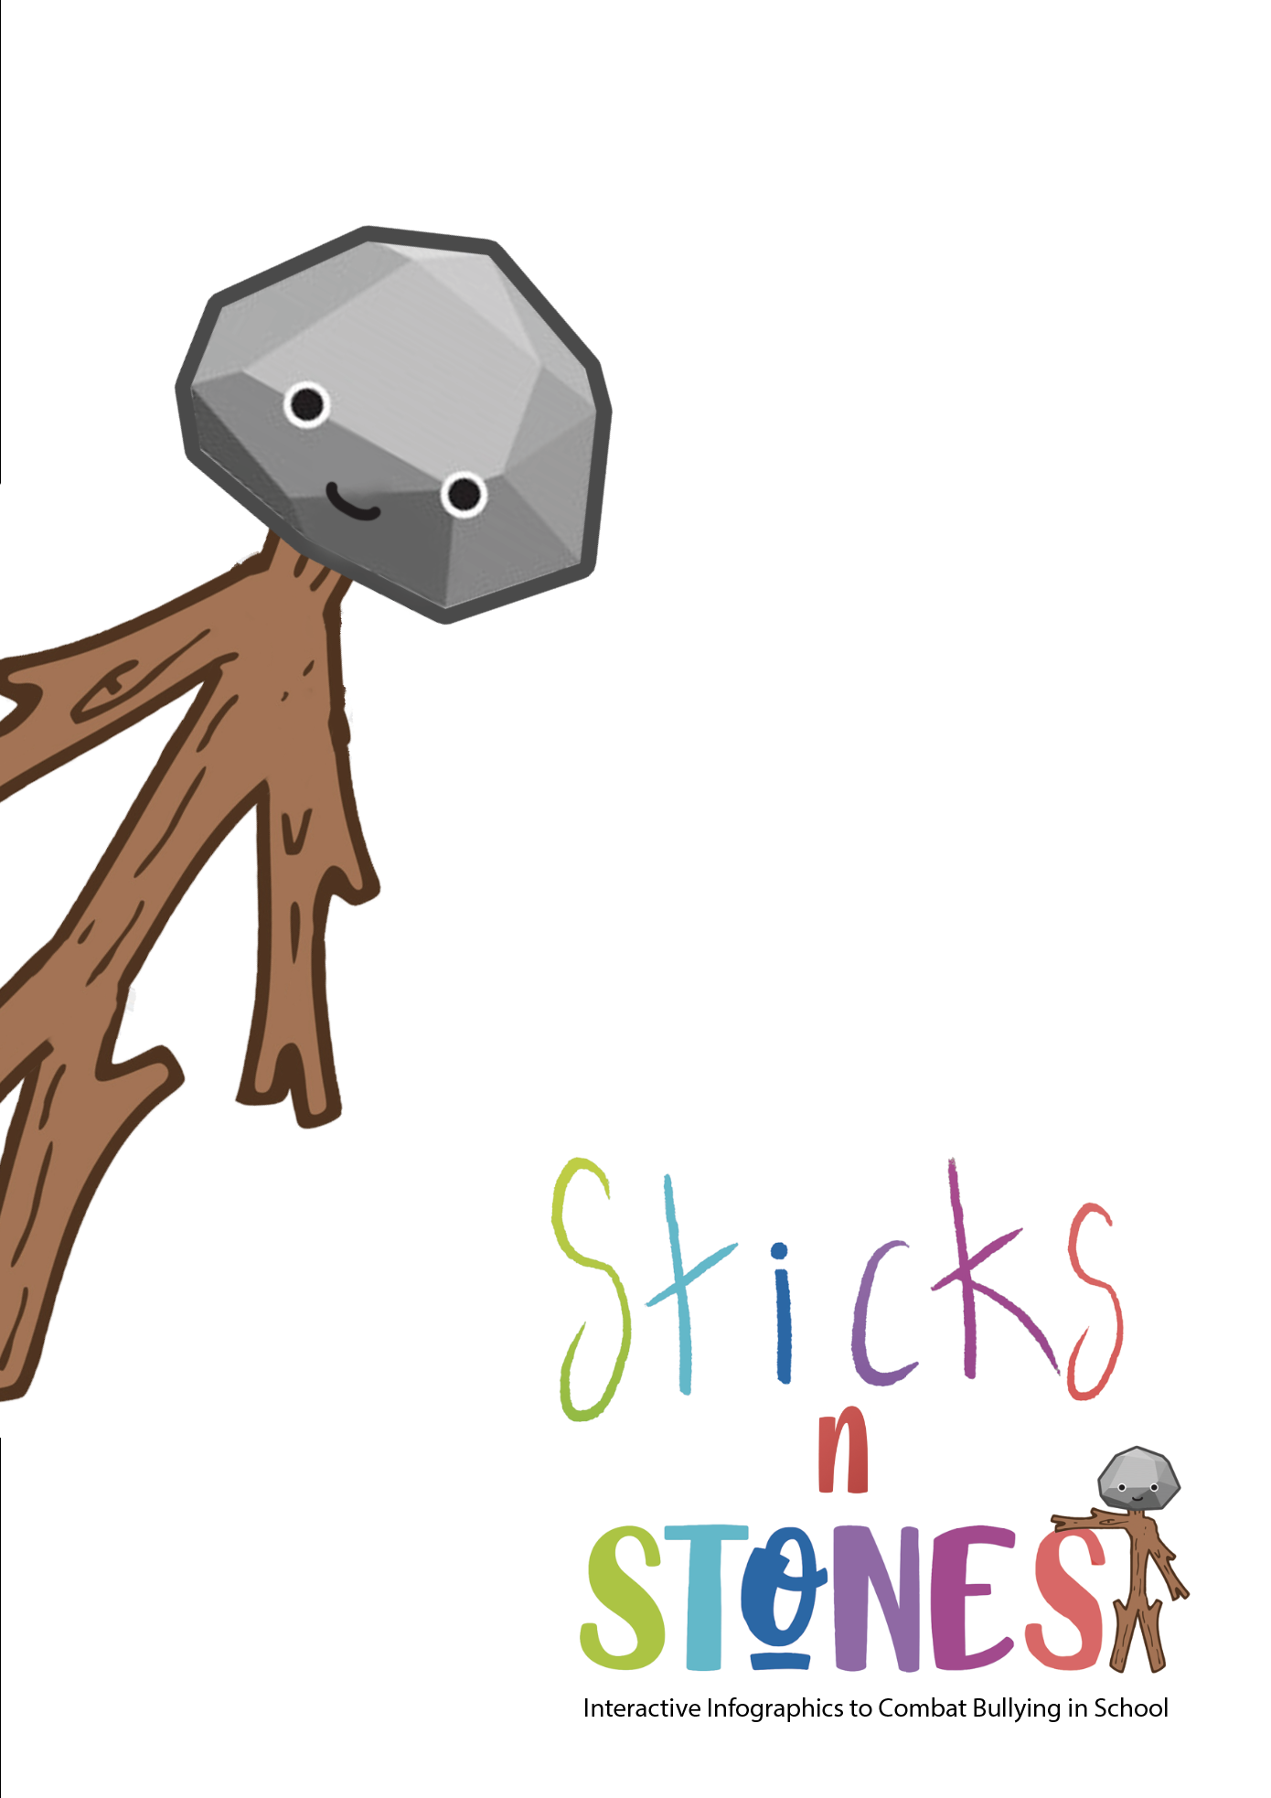

Module title: Digital Content Creation
Designed by: RAFINA School
Aim of the Module |  | This module will include an introduction to interactive platforms, like PowToon, StoryBoardThat, Google Forms, Canva, KAHOOT, LearningApps etc. as well as an introduction to how these can be applied in a primary school setting. This module will also teach primary school teachers some of the key functionalities, features and best practices to follow when using these resources; and will show how they can develop interactive and engaging materials using these software programmes.
TOTAL Learning time |  | SDL | Assessment
9 hrs of which: |  | 7 hrs | 2 hrs
LEARNING OUTCOMES OF THE MODULE

On successful completion of this Module, trainees (primary teachers) will be able to:
Knowledge* | K.3.1. Define interactive platform for education  K.3.2. Describe the 5 general features that makes a platform for education interactive  K.3.3. Name at least two examples of interactive platforms for education  K3.4. Present key functionalities of at least tow examples of interactive platforms for education  K3.5. Emphasize advices and tips on how to use interactive platforms in primary education  K.3.6. Present the main steps about how to use at least one specific interactive platform to create educational digital content
Skills* | S.3.1. Summarise benefits of the interactive platform for education  S.3.2. Judge/analyse through own filter various interactive platforms for education in terms of their value for primary education  S.3.3. Apply pre-designed digital resources offered by interactive platforms for education in own teaching  S.3.4. Create own digital resources with interactive platforms for education  S.3.5. Integrate in own teaching digital resources created by himself/herself with interactive platforms for education  S.3.6. Argue the need for using interactive platforms for education in pandemic times
Attitudes* | A.3.1. Express appreciation of the use of interactive platforms in primary education  ---  ---  A.3.2. Promote the use of educational interactive platforms among peers and colleagues  A.3.3. Offer advice and tips on how to use interactive platforms in primary education to peers and colleagues  A.3.4. Act independently to create educational digital content with interactive platforms and use them in classroom

Module title: Digital Content Creation
Welcome and Introduction to the module | Welcome at:„Digital Content Creation” – Module 3 of the SDL Curriculum in “Sticks ‘n’ Stones”!  The Module is addressed to primary school teachers and has a total duration of 9 hours.  In this module you will learn about the following topics:  - Interactive platforms for education: definition, features and examples (PowToon, StoryBoardThat, Google Forms, Canva, KAHOOT, LearningApps etc.)  - Why and how to use interactive platforms in primary education: explanations, advices and tips  - Practical examples on how to create educational digital content with interactive platforms
Presentation of the learning content and tasks | Interactive platforms for education: definition, features and examples  Definition  An interactive platform for education is:  “An integrated set of interactive online services that provide teachers, learners, parents and others involved in education with information, tools and resources to support and enhance educational delivery and management.”  “A virtual program whose function is to create virtual spaces to share information. It is intended for teachers and students. It is widely used in universities and schools, both face-to-face and online.”  “An integrity of tools and services for writing, storing, disseminating digital communication, manage students activities, searching information etc.”  Features  Customized Learning: the interactive platforms offer personalized content that suits the requirements of various geographies, knowledge levels and competencies.  Train-as-you-go: digital platforms function on a train-as-you-go basis; the learners don’t have to halt their learning process just because they are not present within the educational unit premises.  Instructor-Led Virtual Learning: even while learner browses through a variety of animations, presentations, guidebooks and simulations, an instructor always remains present to interact, clarify, explain and therefore lends the session a dignified ‘human’ touch.  Activity Oriented Learning: the activities included in the interactive platforms (from online quizzes and app simulations to role playing, scenario-based learning, case studies, hands-on practice) make the learning process interesting, informative, useful and increase the learner engagement rate exponentially.  Interactive Tools: the multiple tools and techniques (e.g. eBooks, interactive PDFs, gamification, leader boards, downloadable lessons, editable documents and remote classroom collaborations) enhance interactivity and make way for performance-based outcomes  Comprehensive Outcome Reports: online platforms allow teacher to prepare expertly designed, well-crafted and informative outcome tracking reports on learner progress and assessment results, in a comprehensive manner.  Task  - Find out the top 5 features that make an eLearning platform interactive in the following resourse:  https://www.muvi.com/blogs/5-features-of-interactive-e-learning-platform.html  Examples  There are many Interactive Educational Platforms, either school/class/learning management systems or platforms for creating digital educational resources.  Examples of school/class/learning management systems:  Kinderpedia: https://www.kinderpedia.co/  Edmodo: https://new.edmodo.com/  EasyClass: https://www.easyclass.com/  Google Classroom: https://classroom.google.com  Moodle: https://moodle.org/  Blackboard: https://www.blackboard.com/  Coursera: https://www.coursera.org/  Microsoft Teams: https://www.microsoft.com/  EdApp: https://www.edapp.com/  Examples of online platforms for creating digital educational resources:  PowToon: https://www.powtoon.com/  StoryBoardThat: https://www.storyboardthat.com/  Google Forms: https://www.google.com/intl/en-GB/forms/about/  Canva: https://www.canva.com/  Kahoot: https://kahoot.com/  LearningApps: https://learningapps.org/  Wordwall: https://wordwall.net/  Powtoon is a visual communication platform that gives you the freedom to create professional and fully customized videos your audience will love (engaging animated explainers, videos, video and cam recordings and more, for your classroom).  StoryBoard is an online storyboard with a simple drag and drop interface and a large collection of custom artwork that makes it easy for students and teachers to create great looking storyboards that bring visual learning to life (graphic novels, comics, lesson plans, activities, posters, videos and more).  Google Forms, part of the Google suite (Google Docs, Google Sheets, Google Slides, etc.) is a platform that allows you to manage event registrations, create a quick opinion poll, create and analyse surveys, quizzes, questionnaires and more.  Canva is a free-to-use online graphical tool that combines design, photo editing, and layout to help teachers and students create beautifully finished projects; a powerful online design tool that can transform a class, both in-room and remotely.  Kahoot! is a game-based learning platform that makes it easy to create, share and play learning games or trivia quizzes in minutes. It allows you to unleash the fun in classrooms, offices and living rooms!  LearningAppsis a platform that supports learning and teaching processes with small interactive, multimedia exercises. The exercises can be created and used very easily online. A number of templates (assignment exercises, multiple choice tests, etc.) are available.  Why and how to use interactive platforms in primary education: explanations, advices and tips  Benefits of using interactive platforms in primary education  Teachers often find success when they present the opportunity to use interactive platforms. There are various benefits and effects of using interactive platforms for educational instruction. Some of them include:  • Convenience: 24/7 access from any online computer; accommodates busy schedules; no commuting, no searching for parking.  • Enhanced Learning: Research shows increased depth of understanding and retention of course content; more meaningful discussions; emphasis on writing skills, technology skills, and life skills like time management, independence, and self-discipline.  • Leveling of the Playing Field: Students can take more time to think and reflect before communicating; shy students tend to thrive online; anonymity of the online environment.  • Interaction: Increased student-to-teacher and student-to-student interaction and discussion; a more student-centered learning environment; less passive listening and more active learning; a greater sense of connectedness, synergy.  • Innovative Teaching: Student-centered approaches; increased variety and creativity of learning activities; address different learning styles; changes and improvements can translate to on-ground courses as well  • Improved Administration: Time to examine student work more thoroughly; ability to document and record online interactions; ability to manage grading online.  • Savings: Accommodate more students; increased student satisfaction = higher retention and fewer repeats.  • Maximize Physical Resources: Lessen demand on limited campus infrastructure; decrease congestion on campus and parking lots.  • Outreach: Give students options; reach new student markets; appeal to current students thus increasing enrollments.  Task  - Read the following research:  https://telrp.springeropen.com/track/pdf/10.1186/s41039-018-0078-8.pdf and find out the students’ perception of Kahoot!’s influence on teaching and learning.  Advice and tips on how to use interactive platforms in primary education  1. Simplicity Is Key. It is critical to design distance learning experiences that have very clear instructions and utilize only one or two resources. It’s also best, when possible, to provide resources that students can always access.  2. Establish a Digital Home Base.In the spirit of simplicity, it’s vital to have a digital home base for your students like Canva or Google Classrooms. Students need to feel comfortable going to the same place to access the same tools. The farther away you are from your students, the more important it is to cultivate stability and practice norms.  3. Prioritize Longer, Student-Driven Assignments. To effectively manage your time, prioritize longer, student-driven assignments and tasks that buy you time to keep planning future units. Focus on building toward long-term projects where students have autonomy and a clear set of checkpoints and deadlines that need to be met.  4. Individual Touchpoints Are Game-Changers. What your students will miss the most during the education through interactive platforms is the human connection that is cultivated in your classroom. So is important to create structures for personalized touchpoints with your students. You can create these touchpoints through emails, messages through your learning platform, comments on shared documents, etc. Your students will see your investment and know that you care about them.  Task  - Find more tips in the following resources and follow these that work better for you!  Teachers share their top tips for remote learning:  https://www.irishtimes.com/news/education/start-really-small-teachers-share-their-top-tips-for-remote-learning-1.4209759  What works in online/distance teaching and learning?:  https://www.aitsl.edu.au/research/spotlights/what-works-in-online-distance-teaching-and-learning  7 tips on choosing edtech from a primary teacher: https://digitalagenda.io/insight/7-tips-on-choosing-edtech-from-a-primary-teacher/  EdTech Top Tips for Teachers:https://www.canopy.education/post/edtech-top-tips-for-teachers  5 ways to make virtual learning more interactive: https://www.keystoneacademic.com/news/5-ways-to-make-virtual-learning-more-interactive  10 Simple Tips For Virtual Teaching Beginners: https://www.teachthought.com/technology/virtual-teaching-tips/  Practical examples on how to create educational digital content with interactive platforms: Kahoot! and PowToon.  Using Kahoot! in the Classroom  Introduction  Students will often state that they like instructors who employ active learningstrategies to get students engaged with the class topic. Sometimes, though—particularlyin large lecture classes--it is difficult to get some students to participate in classroomactivities and discussions and assess whether they truly are learning and retaining thecourse material. Kahoot is the perfect solution to create a fun and interactive way for allstudents to learn and comprehend the information.  What is Kahoot?  Kahoot! is a tool that delivers and presents questions to students. It is set up as agame that students can play either individually or in groups. Instructors providestudents with multiple-choice questions, which are projected on a classroom screen.Each question has a limit of 95 characters, is displayed anywhere from 5 seconds to 2minutes, and is restricted to four response options. Students, who will need to create a unique username that can be used throughout a semester, answer these questions withtheir own personal electronic devices (e.g., laptop, smartphone, or tablet) and receivepoints for both response accuracy and promptness. After each question is answered, thecorrect answer will be displayed as well as a scoreboard of the highest point earners. Atany time, instructor can track student progress and scores. Kahoot! also can be2incorporated into online classrooms.  How can I get Kahoot for the Classroom?  Kahoot!’s current service allows free access for all educators. Go to  https://getkahoot.com and click on the tab that says “GET MY FREE ACCOUNT.” Provide your role (i.e., instructor) and your institution, create a username, supply your e-mailaddress, and select a password. To use Kahoot! each time, you will need to decide if youwould like to create a new one or duplicate a prior one. If you decide to create a newKahoot!, you must specify whether it is a discussion question, a survey, or a quiz; if youchoose to duplicate a Kahoot!, you can edit any of the prior questions as needed. Youalso can decide if you would like your game to remain private (for only your personalclassroom use) or be available for public use (for other instructors to also use it in theirclassrooms).  How can I use Kahoot! in the classroom?  Kahoot! provides students with a fun and interactive way to learn classroommaterial. More specifically, Kahoot! can be used to:  1. Present a new topic by assessing what students already know about the topicand what areas they should know. Kahoot! can survey students prior to a course lectureto determine whether students have an understanding of the topic. It also can guideinstructors in selecting their lecture content and identifying the key points to emphasize.  2. Help with vocabulary terms, terminology, and definitions. Because Kahoot!focuses on fast-paced questions, it can assist students with learning course-relatedvocabulary, terminology, and definitions.  3. Poll students about their opinions. Kahoot! allows instructors to presentopposing sides or viewpoints of an argument or dilemma. This presentation is ideal forcourses using case studies as there might be different solutions to the problem. Takingpoll also saves valuable class time that can be used for student discussion.  4. Review for an examination or test. Students like the ability to review classmaterial in a game format. Kahoot! helps them retain the material because it ispresented in a fun and entertaining manner. Because each game can be played morethan once, instructors can repeat the game as a way to enable students to understandwhy their previous answers were incorrect.  5. Learn information in sequential order. Kahoot! recently launched a Jumblemode, which allows students to put things into consecutive order. This allows instructorsto ask questions about chronological or progressive order.  Conclusion  Game formats are always a fun way to create student excitement toward learning.Kahoot! is a tool that motivates and activates students’ learning because it can test theirknowledge, reiterate important concepts, and help them retain information. It alsoprovides instructors with the ability to further create class discussion and student-to-student interaction.  Task  - Watch the tutorials and learn how to useKahoot!  Teacher’s starter guide to Kahoot!: https://kahoot.com/files/2021/06/StarterGuide_0621.pdf  How To Use Kahoot!? | 2020 Tutorial: https://www.youtube.com/watch?v=zBkVp8-CDeo  Complete Tutorial in Kahoot! 2022 Free Account: https://www.youtube.com/watch?v=U8GMbLeeU7A  Using PowToon in the Classroom  Introduction  Communication messages are sent and received every day in classrooms. Often times, the traditional modes of sending messages involve face-to-face standardized lectures, PowerPoint, Prezi, or some type of video.  While these types of channels are functional, they are not always effective given how students differ in their learning styles. These differences are one reason why instructors should consider using PowToon, which is an alternative way to deliver relevant course information.  What is PowToon?  PowToon is an eTool that creates animated videos for personal, educational, or business/professional use. It is a free, web-based (with options to upgrade), user-friendly software that creates presentations via three simple and easy steps: writing a script, recording a voiceover, and adding visuals. Novice users can select one of five looks (i.e., ModernEdge, Whiteboard, Infographic, Cartoon, Corporate) and can choose to edit templates that already have been created, whereas experienced tech users may choose to design their own storyboard and video rather than use a template. (Tutorials and access to live chats are available to aid in the creation and production of these videos.) For a fee, content also can be created by a PowToonist. Once completed, these animation videos can be exported and shared on YouTube, Facebook, Twitter, Google+, LinkedIn, or e-mail.  How can I get PowToon for use in the classroom?  Go to www.powtoon.com , click on the “sign up” tab, and create your free account. With this account, you can create your own PowToon video by searching the User Gallery for templates (e.g., syllabus, welcome video) that can be modified easily.  You can add up to 30 students on your account or you can have your students create their own accounts. While the standard free plan includes 100Mb, basic image quality, 100Mb of storage and video of up to five minutes, three additional plans are available.  The pro plan is $19 a month and includes 2 GB of storage and up to 15 minutes per video; the business plan is $39 per month and includes 10 GB of storage, full HD quality and resolution, and up to 60 minutes of HD or full HD of 8 minutes per video; and the team plan is $46 per month, which includes 10 GB per seat storage, full HD quality, and up to 60 minutes HD or full HD 8 minutes per video.  How can I use PowToon in the classroom?  PowToon can be used by instructors and students to:  1. Create introductory videos for a course. Before the start of the semester, instructors can create a short video to introduce both themselves and the course (e.g., syllabus statements, classroom policies) to their students. Instructors have the option to export this video and post it to the course management system, e-mail it to the students, or show it on the first day of the course. Similarly, instructors can create a PowToon for their students on how to use PowToon (or any other how to topic). Truly, a training video could occur for any course that requires instructions to be given.  2. Preview a guest speaker. Posting a video about a guest speaker can be useful for students. Understanding who the speaker is, the speaker’s background, and the purpose for the course visit allows students to plan ahead and prepare for the speaker ahead of time. Likewise, students could be tasked with creating and sending a thank you video to the guest speaker.  3. Introduce or conclude lesson plans/subjects. Introducing a new subject area of the course in order to highlight its relevance can be a quick way to gain the attention and interest of students so that they are excited about their upcoming learning. When concluding a particular course unit, a review is always helpful. A PowToon can not only serve as a review to the end of a unit, but also can serve as a study aid for an upcoming exam.  4. Create examples of course assignments/projects. Depending on the course, an animated video can demonstrate to students the essential components of an upcoming assignment (e.g., a review, speech, presentation, infomercial, commercial, debate). Items to include on this course assignment/project video can include its learning objectives, needed course materials, sections/parts, and due dates.  5. Promote a department event or new course. If your department is hosting aparticular event, a PowToon could be created and released to help advertise theupcoming event. If a new course is being offered in a department, a video could becreated and sent to prospective students to gauge their interest.  Conclusion  PowToon is a simple and easy to use tool for both instructors and students alike.This animation tool provides instructors and students with a fun and creative way tosend messages in an engaging format.  Task  - Watch the tutorials and learn how to create your first video!  PowToon Basics:https://www.abss.k12.nc.us/cms/lib/NC01001905/Centricity/Domain/6252/BMSPowToonQuickReference.pdf  Powtoon_1:  https://mahfuzah.weebly.com/uploads/1/1/7/5/117591906/powtoon__1_.pdf  Powtoon Tutorial - Creating Your First Powtoon: https://www.youtube.com/watch?v=bRqO5MasiFk  Tutorial: How to Use Powtoon FREE: https://www.youtube.com/watch?v=lEQiZQi-aGY  Tasks for in-depth understanding of interactive platforms for education  - Read the following document “Introduction to Online Teaching and Learning” https://www.wlac.edu/online/documents/otl.pdf and  - From the chapter Benefits of Online Teaching and Learningselect the most important in your opinion benefits of online teaching in the specific educational environment where you work.  - Answer the questions of the Quiz: Is Online Teaching Right for Me?to find out if and to what extent online teaching is right for you.  - Read the following article “The Challenges and Constraints of Online Teaching and Learning in the New Normal Environment”https://hrmars.com/papers_submitted/9825/the-challenges-and-constraints-of-online-teaching-and-learning-in-the-new-normal-environment.pdfand make a comparison with the issues and challenges you encounterusing interactive platforms for education.  - Read the following research “TEACHERS’ EXPERIENCES WITH ONLINE TEACHING…”https://sciendo.com/pdf/10.2478/seeur-2020-0009 answer the INTERVIEW QUESTIONSbased on your personal experience using Zoom or any other interactive platform you have used during your online teaching experience and compare your answers with the research results.  - Find more resources for Digital Content Creation in the TCC VET EU Erasmus+ Project “Toward a Continuous Cycle of digital literacy learning for VET teachers:  https://thalys.gr/course/index.php?categoryid=43
Final Assessment  of achieved LOs through the Module | Use any of the interactive platforms, like PowToon, StoryBoardThat, Google Forms, Canva, KAHOOT, LearningApps etc. to create one anti-bullying digital resource that you intend to use in your professional activity (in the classroom, with your pupils).

