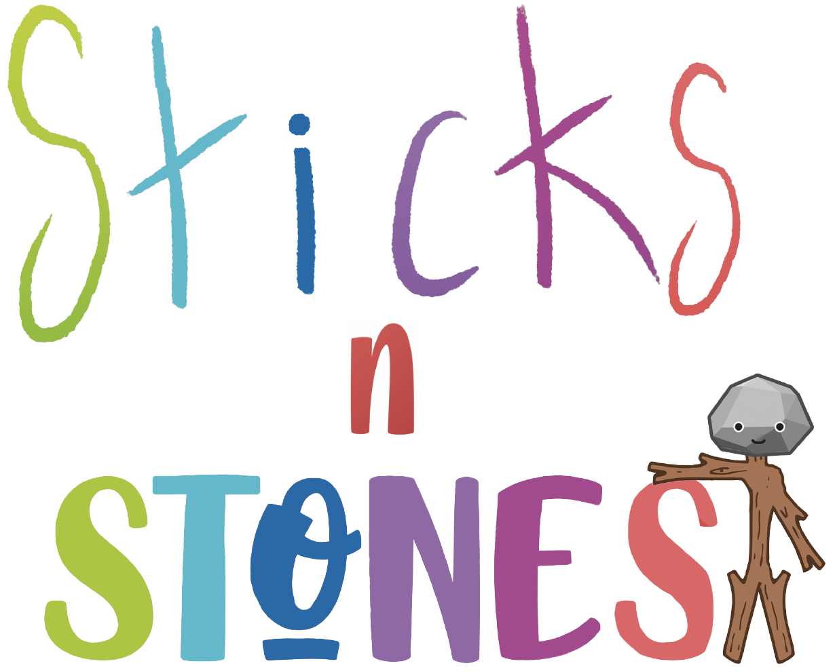

Annex 3.1: Slip writing

Think about how you could use interactive platforms in the teaching with your primary school pupils.

Write 5 main questions you might have on that, and to which the Sticks’n’Stones modules implemented (taught) so far did not answer you:

No. | Question
1
2
3
4
5
Time: 10 minutes

